**Home page view.**

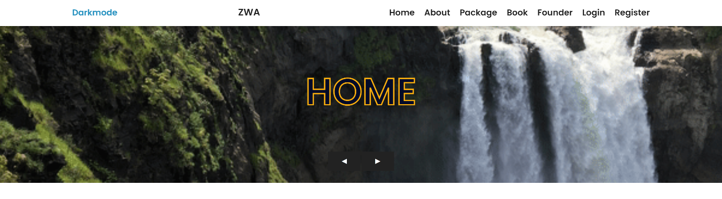

**On the main page we see pages for unregistered users: Home, About, Package, Book, Founder, Login, Register.**

**If the user is registered and logged in, then he sees the Logout button and the Personal Account page.**

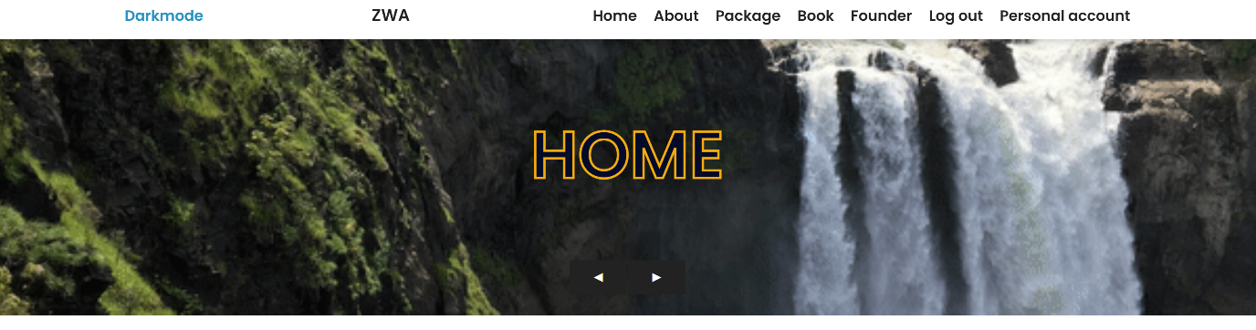

**User registration looks like this.**

You must enter your personal data for successful registration. If the user tries to enter incorrect characters, checking through JavaScript and PHP will show errors. Also made protection from XSS attacks.

We also have a connected Database that checks the login and email for uniqueness. That is, you cannot register with the same mail or login more than 2 times.

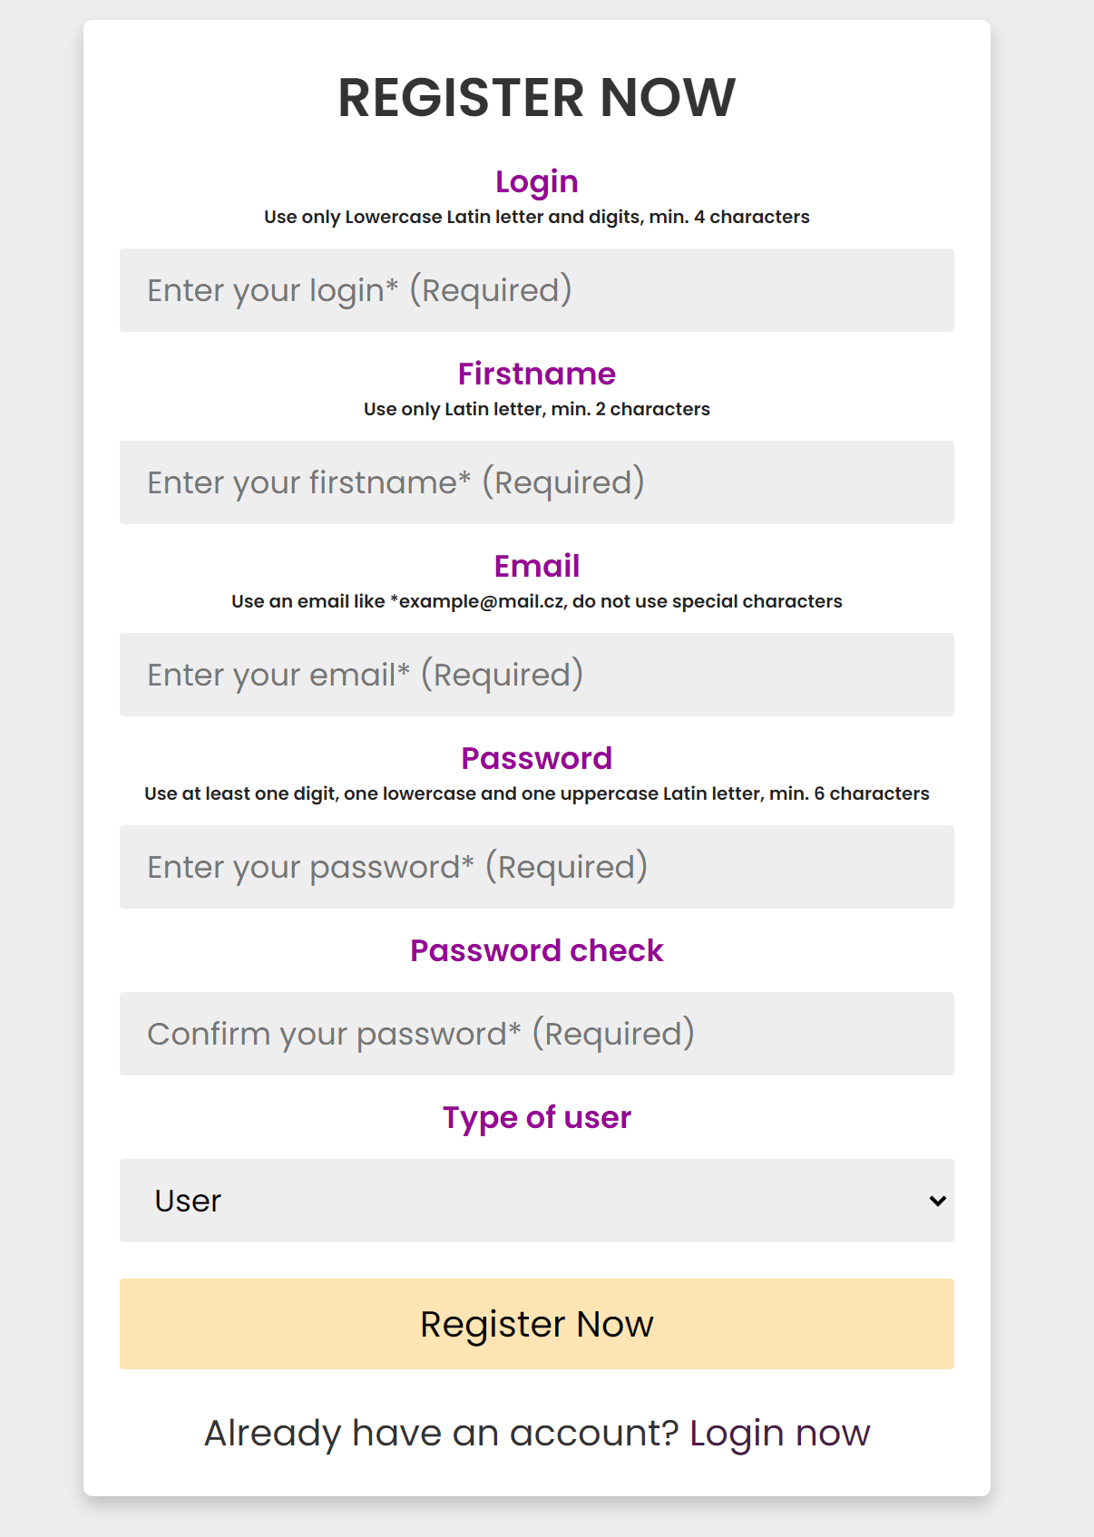

**Checking the uniqueness of the login.**

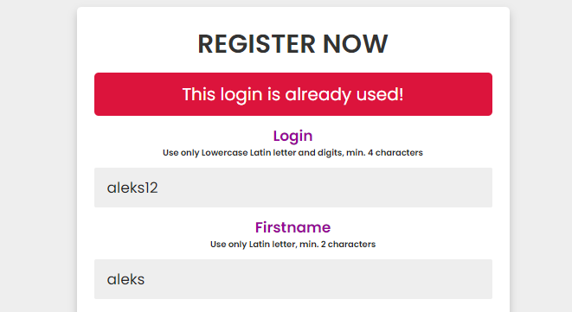

**Checking the uniqueness of an email.**

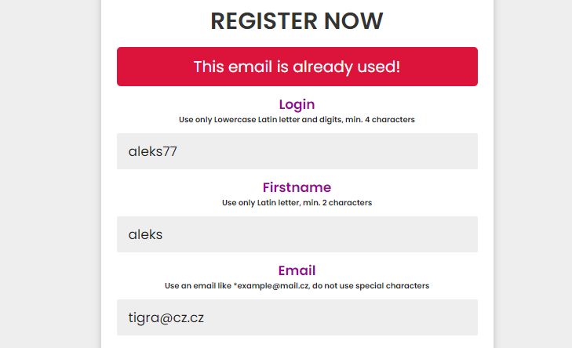

**Incorrectly completed registration form.**

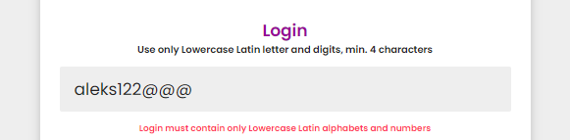

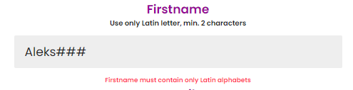

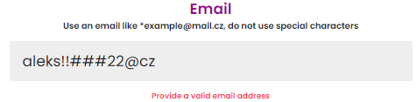

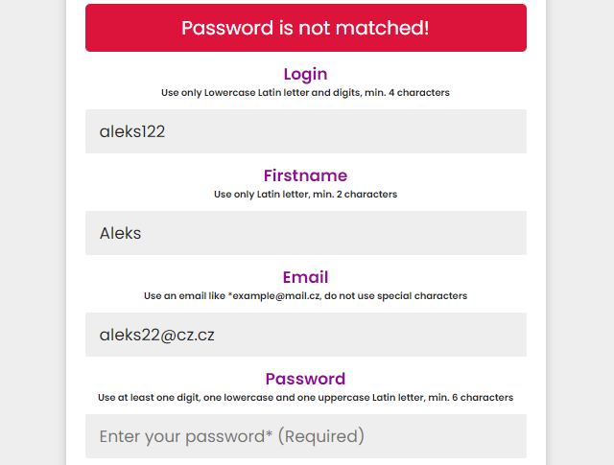

**In case of successful registration, the form will be submitted. All data except the password will be readable. The password is encrypted using the password_hash function and salted.**

The password in the database looks like this $2y$10$6uaC8xYbbW/vnAF1kgH4QeRIu3Zv8PJZolF3o9y8fbMr40a6T66T. It is very difficult to crack it.

**In order to access your personal page, the user must enter a username and password.**

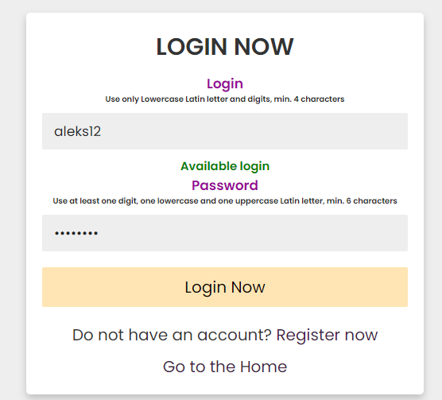

**The case when the user entered a non-existent login.**

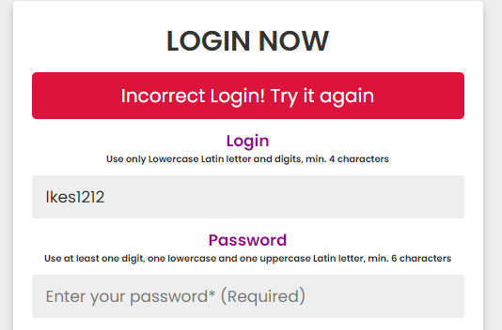

**The case when the user entered the wrong password.**

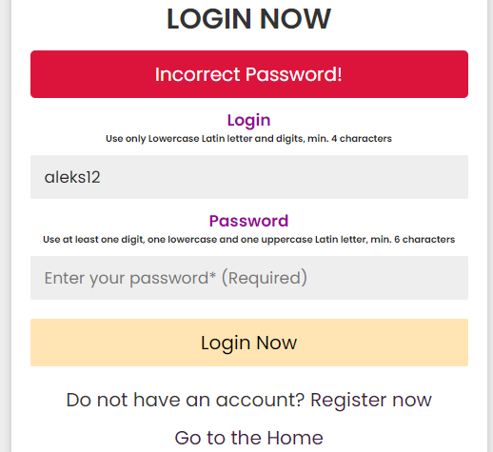

**In case of successful data entry, the user will be redirected to his personal page.**

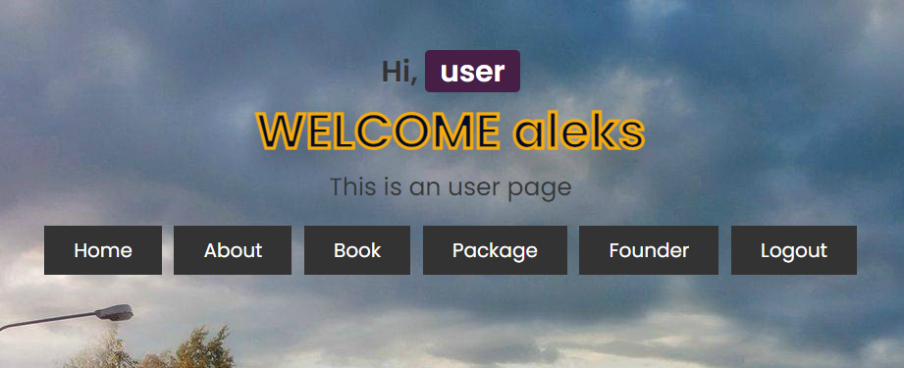

**On the About page you can select a section with comments**

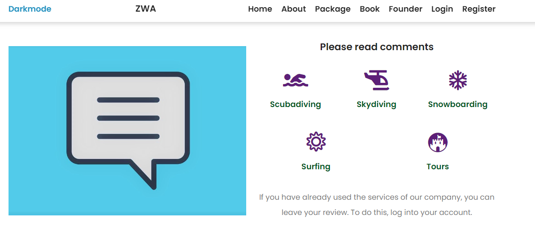

**If you go to one of these pages, you will see this.**

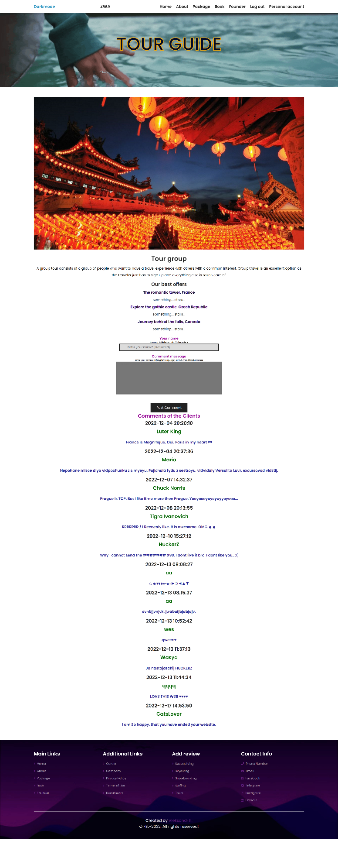

**Since the registered user is logged in, he can leave a comment.**

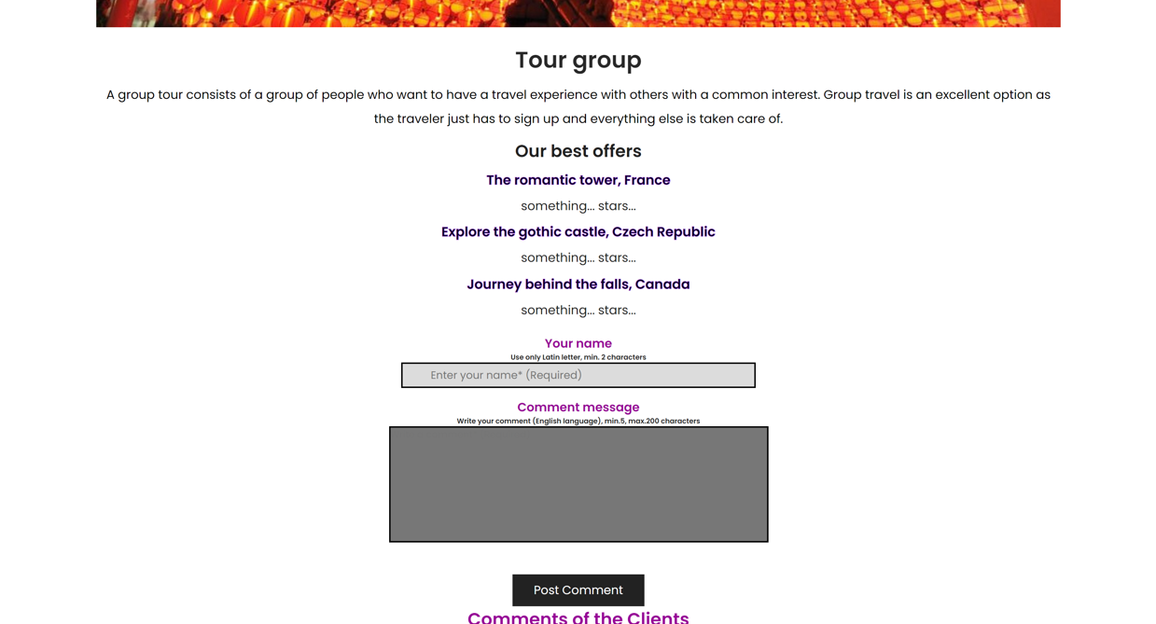

**If the user is unregistered, then he cannot leave a comment.**

**He can only read comments.**

**This is how the page for unauthorized users looks like.**

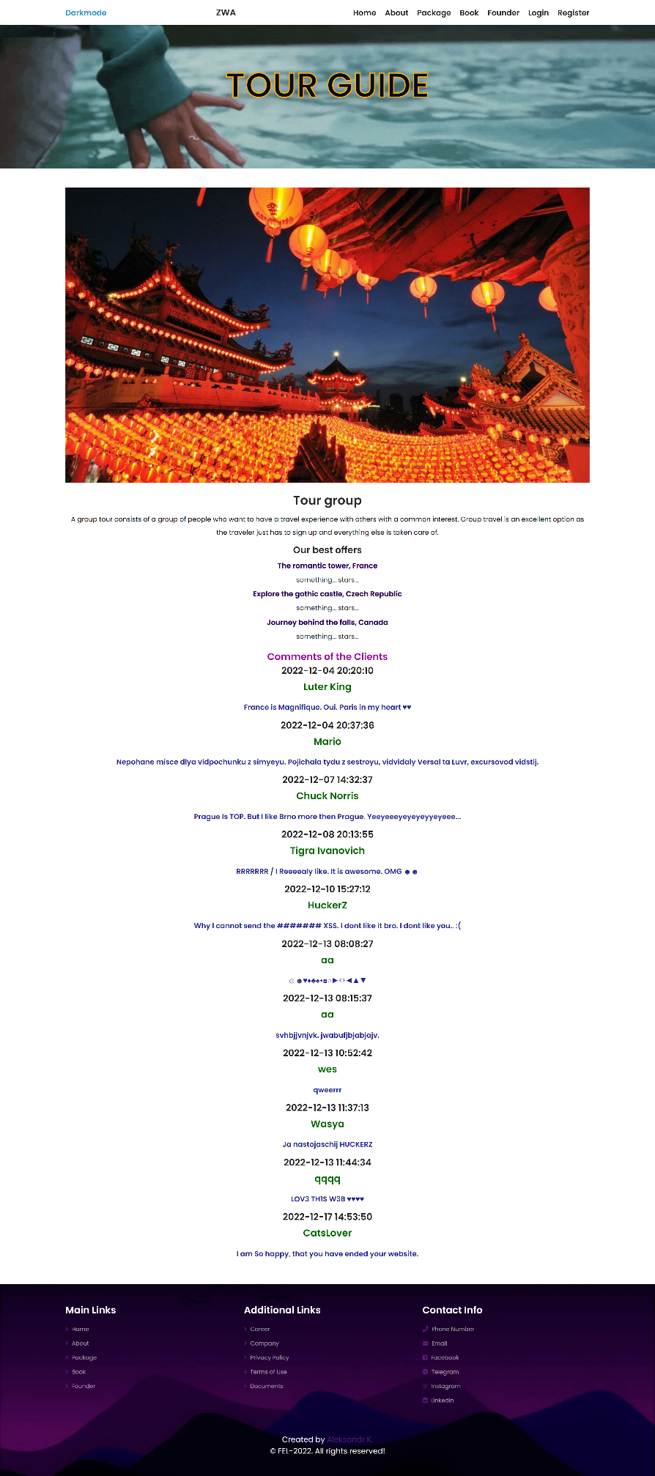

**Also in the Company section you can see the contacts of partners in other countries.**

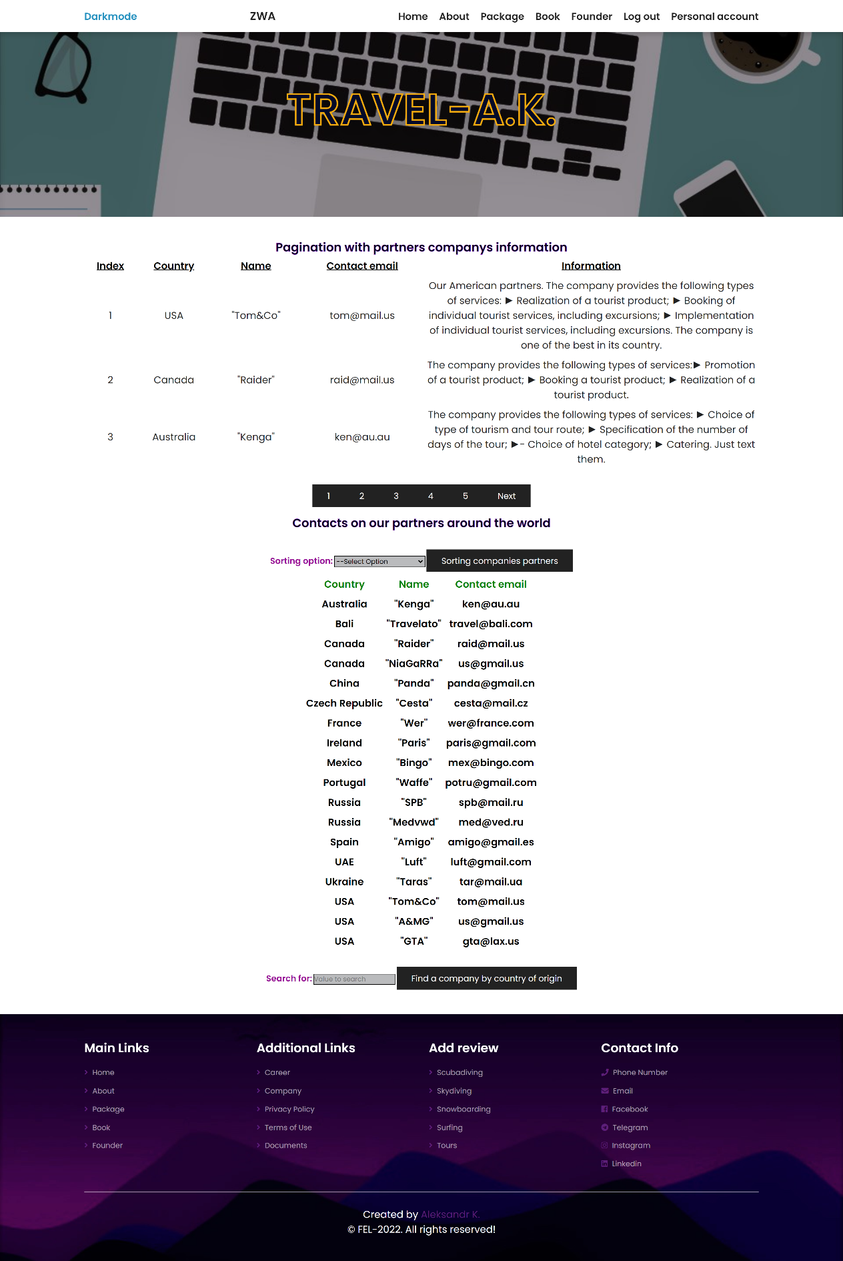

**It is possible to sort companies alphabetically (from A to Z, and vice versa).**

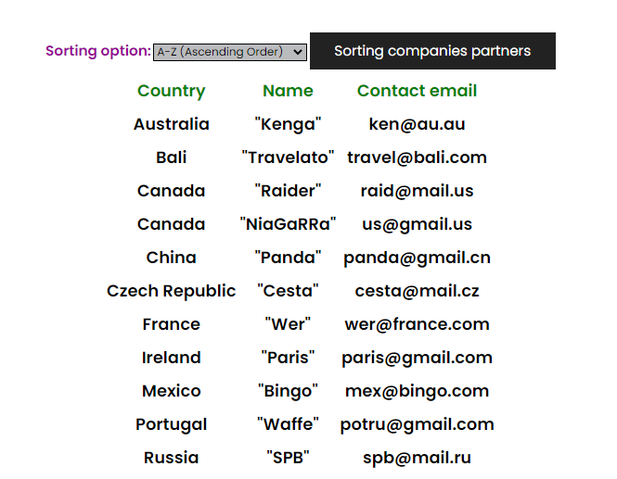

**Sort in reverse alphabetical order.**

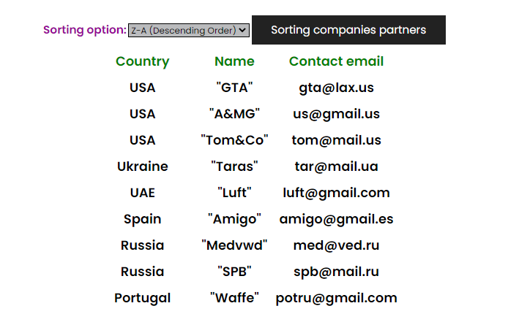

**There is a function to search for a company by country of origin. This feature is only available to the admin.**



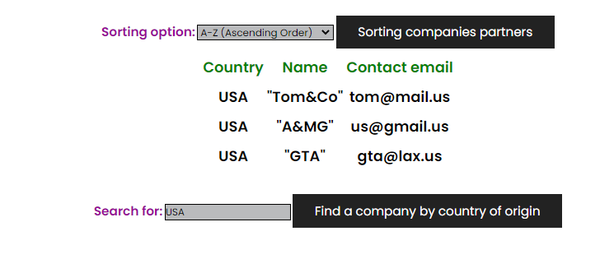

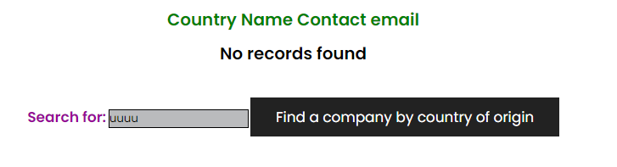

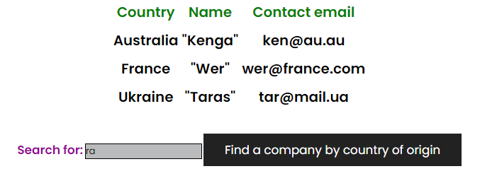

**View travel packages.**

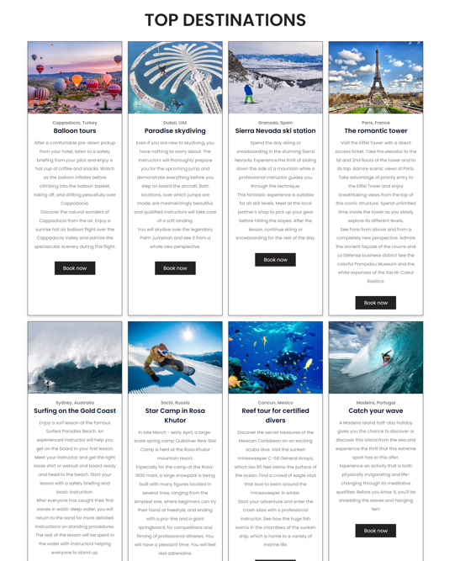

**Booking travel packages.**

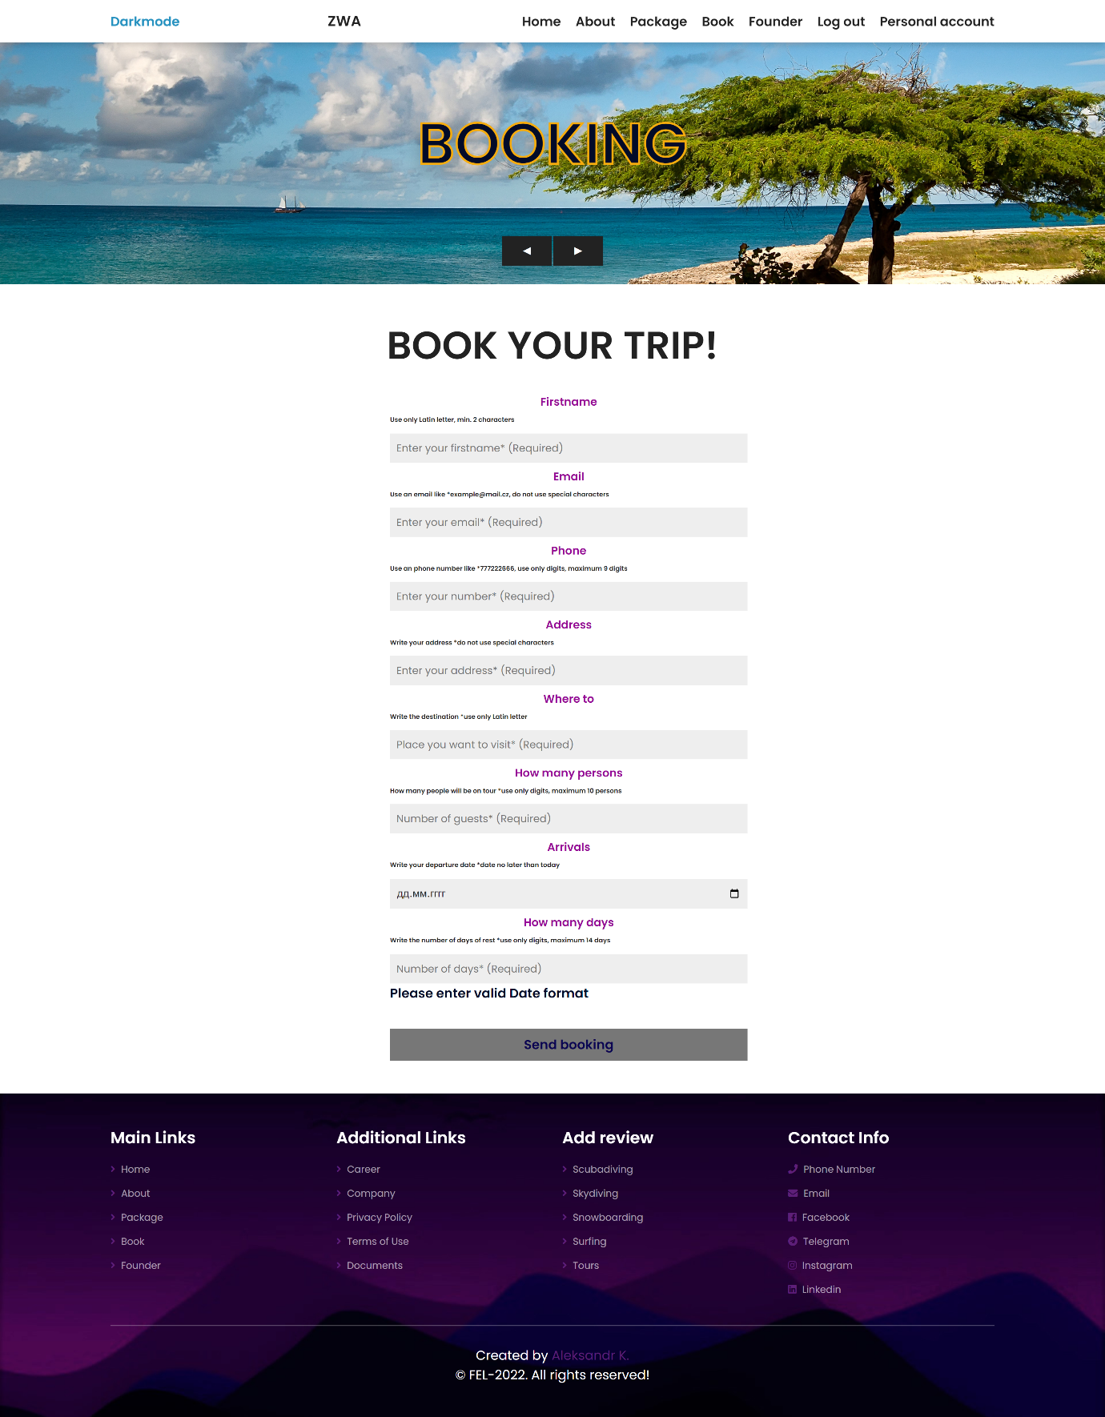

**For unregistered users**

Footer looks like this. We see the main and additional pages.

Also in the Contacts section, you can call the founder of the website, write a message to email and e-mail, add as friends on Facebook and LinkedIn.

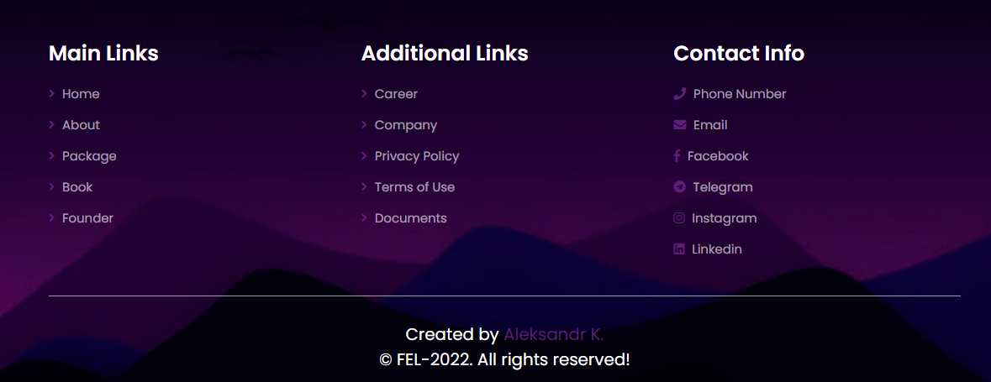

**For registered users**

**In Footer, you can see another section with comments for each topic of the tour package.**

